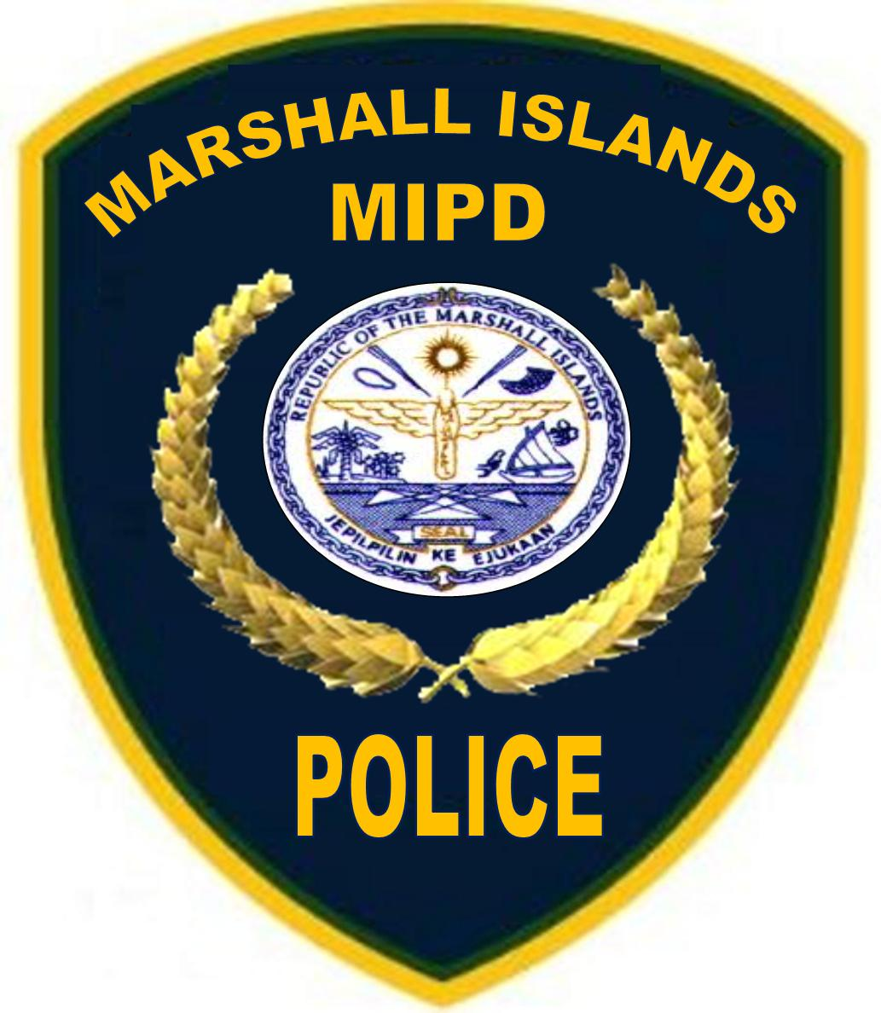
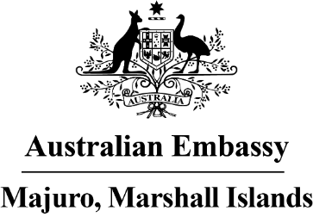

Joint Press Release

Republic of the Marshall Islands and Australian cooperation on maritime security

Building on 32 years of partnership, the Republic of the Marshall Islands and Australian governments continue to cooperate closely on maritime security.
The RMI Police Department and Sea Patrol welcome the substantial contribution of the Australian Department of Defence and particularly Royal Australian Navy for their ongoing support. An integral component of our cooperation program are the Australian Navy technical advisors who have been helping build Sea Patrol’s capacity to deliver maritime surveillance, search and rescue and other essential marine capabilities across the RMI.
The Lomor 3 will be transported to Australia from 10 June for repairs, ensuring its operating life continues to 2024. The Lomor 3 will be placed onto another vessel in Majuro on 9 June, via a contactless process in the lagoon, in accordance with RMI’s COVID-19 protocols.
The delivery of the new Guardian-class Patrol Boat will occur by mid-2024. This timeline allows for the extensive crew training required for the new vessel which has been delayed by COVID-19.
For further media enquiries please contact: majuro.embassy@dfat.gov.au.

